Ex. No. 3 | IDENTIFYING ODD OR EVEN NUMBER IN UiPath
Date of Exercise | 18/12/2025

AIM
To check whether the given number is odd or even.
DESCRIPTION
This experiment is designed to identify whether a given number is Odd or Even using UiPath Studio. In this workflow, a number is taken as input (from the user or assigned to a variable) and checked using the modulus operator (Number Mod 2). If the remainder is 0, the number is Even; otherwise, it is Odd. The result is displayed using a Message Box or Write Line, helping to understand the use of If conditions, variables, and decision-making logic in UiPath automation.
PROCEDURE:
Step 1: Open UiPath studio and click process to start a new project.
Step 2: Create a new blank process by giving a name and give create.
Step 3: Click Open main workflow.
Step 4: From activities select Input dialog box and drop it. Type the Dialog title, Input label and value entered in the dialog box.
Step 5: For the value entered num1 create variable num1 and select variable type as INT32.
Step 6: From activities select else if and type “num1 mod 2 = 0” drop it in main workflow.
Step 7: In the then section, from activities select message box and type even. If the condition satisfies it will display even.
Step 8: From activities select message box and drop it in else section. And type odd so that it displays odd if the condition won’t satisfy.
Step 9: Save it and run the sequence.

OUTPUT:
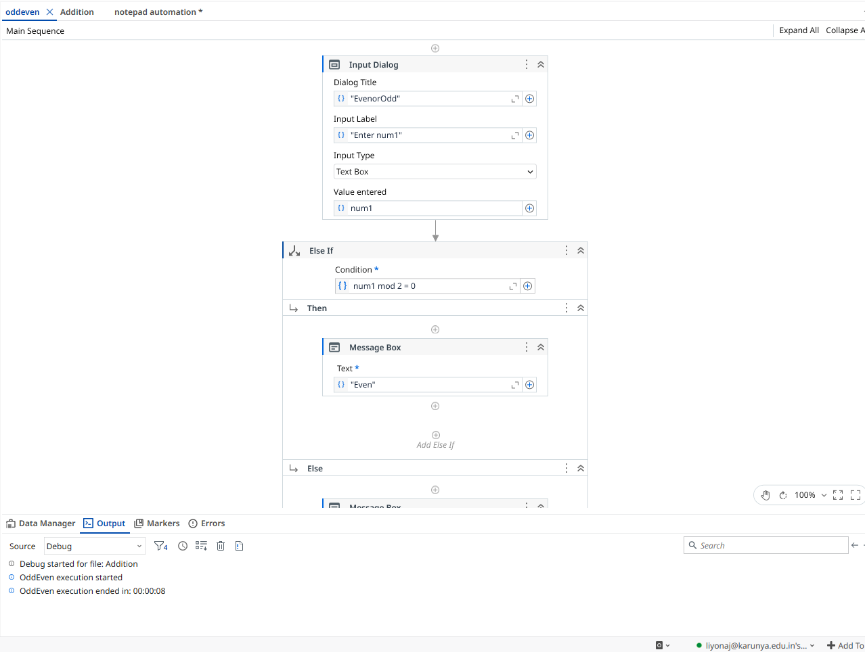

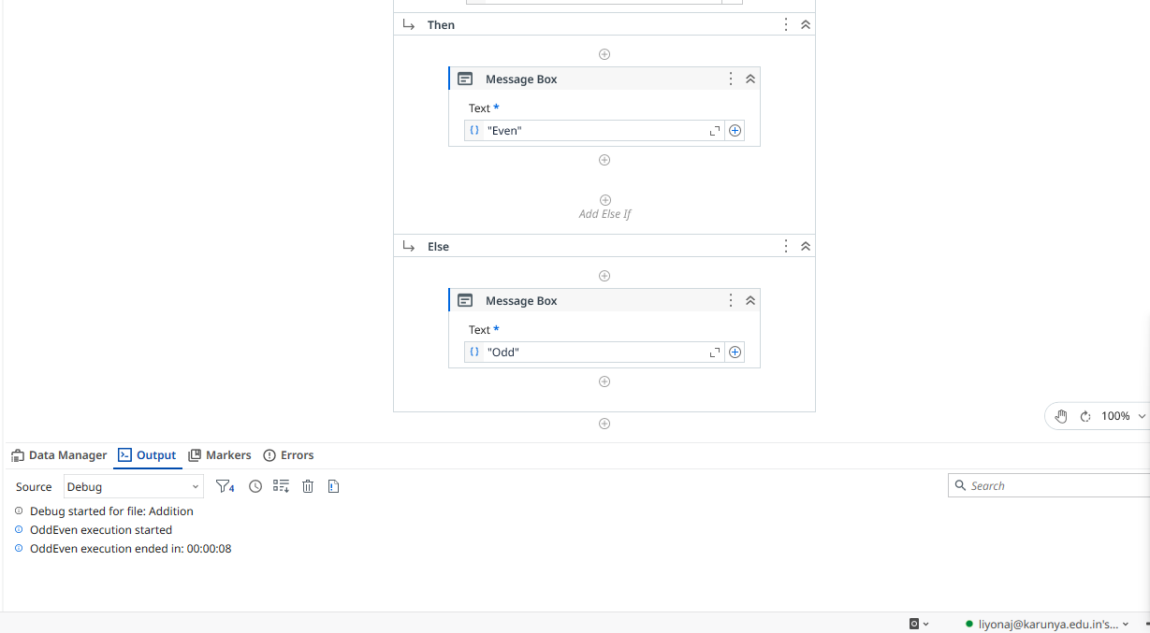
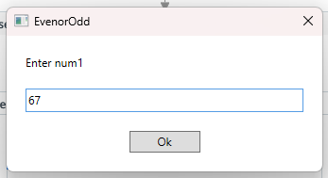

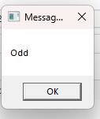

Result
Thus, the given number is odd or even is checked successfully.

